DEFENDING THE DIGITAL DOMAIN BERT-POWERED DEEP LEARNING FOR AGGRESSION DETECTION IN TEXT STREAMS

Submitted in partial fulfillment of the requirements for the award of
Bachelor of Engineering degree in Computer Science and Engineering

By

GORANTLA CHANDRA SEKHAR (Reg. No - 40110398 )
ANGALAKURTHI BRAHMAIAH (Reg. No - 40110091 )



DEPARTMENT OF COMPUTER SCIENCE AND ENGINEERING
SCHOOL OF COMPUTING

SATHYABAMA

INSTITUTE OF SCIENCE AND TECHNOLOGY

(DEEMED TO BE UNIVERSITY)

CATEGORY -1 UNIVERSITY BY UGC
Accredited with Grade “A++” by NAAC | 12B Status by UGC | Approved by AICTE
JEPPIAAR NAGAR, RAJIV GANDHI SALAI,
CHENNAI - 600119

April - 2024


DEPARTMENT OF COMPUTER SCIENCE AND ENGINEERING

BONAFIDE CERTIFICATE
This is to certify that this Project Work is the bonafide work of GORANTLA CHANDRA SEKHAR (40110091) and ANGALAKURTHI BRAHMAIAH (40110091) who carried out the project entitled “DEFENDING THE DIGITAL DOMAIN : BERT-POWERED DEEP LEARNING FOR AGGRESSION DETECTION IN TEXT STREAMS” under my supervision from November 2023 to April 2024.

Internal Guide
Dr. J. JESLIN SHANTHAMALAR M.E., Ph. D.

Head of the Department
Dr. L. LAKSHMANAN, M.E., Ph. D.

Submitted for Viva Voce Examination held on

Internal Examiner External Examiner
DECLARATION

I, Gorantla Chandra Sekhar (Reg.No- 40110091), hereby declare that the Project Work entitled “DEFENDING THE DIGITAL DOMAIN: BERT-POWERED DEEP LEARNING FOR AGGRESSION DETECTION IN TEXT STREAMS” done by me under guidance of Dr.G KALAIARASI, M.E.,Ph.D., is submitted in partial fulfillment of the requirements for the award of Bachelor of Engineering degree in Computer Science and Engineering.

DATE:

PLACE: Chennai SIGNATURE OF THE CANDIDATE

ACKNOWLEDGEMENT

I am pleased to acknowledge my sincere thanks to Board of Management of Sathyabama Institute Of Science and Technology for their kind encouragement in doing this project and for completing it successfully. I am grateful to them.
I convey my thanks to Dr. T.Sasikala M.E., Ph. D, Dean, School of Computing, Dr. L. Lakshmanan M.E., Ph.D., Head of the Department of Computer Science and Engineering for providing me necessary support and details at the right time during the progressive reviews.
I would like to express my sincere and deep sense of gratitude to my Project Guide Dr. G. KALAIARASI,M.E.,Ph.D., for her valuable guidance, suggestions and constant encouragement paved way for the successful completion of my project work completed.
I wish to express my thanks toall Teaching and Non-teaching staff members of the Department of Computer Science and Engineering who were helpful in many ways for the completion of the project.

ABSTRACT

Cyberbullying has become a growing concern in the digital age, affecting the well-being of its victims. To address this issue, a deep learning-based approach for cyberbullying detection using the Bidirectional Encoder Representations from Transformers (BERT) model was proposed in this paper. It has several advantages over the existing models in NLP, making it a powerful tool for various NLP tasks. Firstly, BERT is bidirectional it takes into account the context of a word from both the left and the right side in a sentence. This allows for a more comprehensive understanding of the meaning of a word in a given context. Additionally, BERT is pre-trained on a large corpus of text, providing a solid base for various NLP tasks. This pre-training allows it to perform well even without fine-tuning for specific tasks. Furthermore, BERT can be fine-tuned for specific NLP tasks, allowing for transfer learning from the pre-trained model to improve the performance for a particular task. BERT is a state-of-the-art pre- trained transformer-based deep learning model for natural language processing tasks. The pre-trained BERT model was finetuned on a large dataset of text messages annotated for cyberbullying. The aim of the fine-tuning process was to train the model to predict whether a given text message contains cyberbullying or not. This paper demonstrates the effectiveness of the BERT model for cyberbullying detection and highlights the potential of deep learning- based approaches for addressing this important problem. The proposed approach has the potential to be applied in real-world settings for the automatic detection of cyberbullying in online text messages.

TABLE OF CONTENTS
CHAPTER NO. | TITLE |  | PAGE NO.
 | ABSTRACT |  | IV
 | LIST OF FIGURES |  | VII
 | LIST OF ABBREVIATIONS |  | VIII
1 | INTRODUCTION |  | 1
2 | LITERATURE SURVEY |  | 7
 | 2.1 | Inferences from Literature Survey | 7
 | 2.2 | Open problems in Existing System | 13
3 | REQUIREMENTS ANALYSIS |  | 16
 | 3.1 | Feasibility Studies/Risk Analysis of the Project | 16
 | 3.2 | Software Requirements Specification Document | 20
4 | DESCRIPTION OF PROPOSED SYSTEM |  | 21
 | 4.1 | Selected Methodology or process model | 21
 | 4.2 | Architecture / Overall Design of Proposed System | 23
 | 4.3 | Description of Software for Implementation and Testing plan of the Proposed Model/System | 24
 | 4.4 | Project Management Plan | 24
 | 4.5 | Financial report on estimated costing (if applicable) | 25
 | 4.6 | Transition/ Software to Operations Plan (as applicable) | 27

5 | IMPLEMENTATION DETAILS |  | 28
 | 5.1 | Development and Deployment Setup | 28
 | 5.2 | Workflow with Models | 30
6 | RESULTS AND DISCUSSION |  | 36
7 | CONCLUSION |  | 41
 | REFERENCES |  | 42
 | APPENDIX |  | 44
 | A. SOURCE CODE |  | 44
 | B. SCREENSHOTS |  | 48
 | C. RESEARCH PAPER |  | 51
 | - D. CERTIFICATE

LIST OF FIGURES
FIG. NO. | FIGURE NAME | PAGE NO.
2.1 | Existing System | 5
2.2 | Pre-Treaining & Fine Tuning for Bert model | 7
2.3 | Proposed System | 8
3.1 | Development Model | 10
4.1 | System Architecture | 18
6.1 | Confusion Matrix | 25

LIST OF ABBREVIATIONS
ABBREVIATION | EXPANSION
API | Application Programming Interface
CPU | Central Processing Unit
FPS | Frames Per Second
GPU | Graphics Processing Unit
IOU | Intersection over Union
IOT | Internet of Things
MAP | mean Average Precision
SORT | Simple Online and Realtime Tracking
SSD | Single Shot MultiBox Detector

CHAPTER 1

INTRODUCTION
Cyberbullying is a form of bullying that takes place using digital technologies, such as the internet, social media platforms, and mobile phones. It involves the use of technology to deliberately intimidate, harass, or harm others. This can take many forms, such as sending threatening messages, spreading rumors or false information, or sharing sensitive or embarrassing photos or videos. Cyberbullying can have a significant impact on its victims, including feelings of fear, anxiety, and depression. Unlike traditional forms of bullying, cyberbullying can reach a large audience, as the abusive messages and images can be easily shared and spread online. This can make it difficult for victims to escape the abuse, as it is always accessible through their digital devices. Cyberbullying is a growing concern, particularly among young people who are among the most frequent users of digital technologies. While the anonymity and distance provided by digital technologies can make it easier for individuals to engage in cyberbullying, it can also make it more difficult for authorities to identify and hold perpetrators accountable for their actions. As such, it is important for educators, parents, and policymakers to be proactive in addressing cyberbullying, through education and awareness programs, responsible use policies, and the development of effective interventions and support for victims. Additionally, using sentiment analysis algorithms or machine learning models trained specifically for cyberbullying detection can help detect and classify media platforms and other digital technologies.Additionally, using sentiment analysis algorithms or machine learning models trained specifically for cyberbullying detection can help detect and classify abusive messages and images. Twitter has policies in place to address cyberbullying and others forms of abuse. This includes the option to block or report accounts that engage in such behavior.
A feasibility study is an analysis that considers all of a project's relevant factors- including economic, technical, social. In this we examine several feasibilities where existing and software equipment were sufficient for completing the project.
- Economic Feasibility
- Technical Feasibility
- Social Feasibility

The study is accomplished to check the monetary effect that the gadget may have on the corporation. the quantity of fund pour in research and development of gadget is confined. The expenditure is justified.

This is achieved to test the technical feasibility this is, the technical necessities of the system .Any system advanced must not have an excessive demand on available technical recourses. The evolved system needs to have tolerable necessities and are required for enforcing this machine. Our task has tolerable technical requirements.

The element of study is to check the extent of recognition of the machine with the aid of the person. This includes the technique of schooling the user to use the system efficaciously.

Cyberbullying detection can help identify and prevent instances of online abuse, harassment, and intimidation. By analyzing text data, including social media posts, comments, and messages, machine learning models can be trained to recognize patterns and features that are associated with cyberbullying.

CHAPTER 2
LITERATURE SURVEY
In a study by D. Rios and J. De La Rosa, the authors conducted a comparison of various machine learning techniques for detecting cyber bullying on online social networks. The techniques evaluated included logistic regression, decision trees, random forests, and SVMs. The results showed that SVM achieved the best performance among the tested algorithms. The aim of the study was to determine the most effective machine learning technique for detecting cyber bullying on social media platforms. In a research effort conducted by R. Tiwari, A. Aggarwal, and N. Goel, the authors examined the use of deep learning techniques for detecting cyber bullying on social media platforms. The deep learning models studied LSTM networks and CNNs. The results of the study showed that the LSTM model was the most effective among the models tested, with the highest accuracy and F1-score. This study aimed to provide insights into the performance of deep learning models for detecting cyber bullying in the context of social media. Overall, the study provides valuable information on the potential of deep learning models for detecting cyber bullying on social media platforms. It highlights the importance of selecting appropriate models and features for this task, and the potential for using deep learning to effectively detect and address the problem of cyber bullying. In a study by B. M. Alghamdi and M. Algarni, the authors explored the use of ensemble methods for detecting cyber bullying in social media. These methods combined the predictions of multiple models to improve the overall performance of the system. The authors also employed term frequency-inverse document frequency and sentiment analysis as features to represent the text data in their models. These features were used to capture the most important words in the text and the overall sentiment expressed.

In a study by R. Bhutani and P. Kanungo, the authors conducted a comparative study of various ML algo’s for detecting cyberbullying on the popular social media platform, Twitter. The algorithms included logistic regression, decision trees, random forests, and support vector machines. The results of the study revealed that support vector machines outperformed the other algorithms in terms of accuracy and performance. This suggests that SVM may be a suitable approach for detecting cyber bullying on Twitter and other similar platforms. Overall, the study provides valuable insights into the performance of different machine learning algorithms for detecting cyber bullying on social media. It highlights the importance of selecting appropriate algorithms and features for this task, and the potential for using machine learning to effectively detect and address the problem of cyber bullying. E. Demirtas, M. O. Toker, and M. Gokerconducted a study aimed at detecting cyber bullying on social media through the use of machine learning techniques.

2.1 INFERENCES FROM LITREATURE SURVEY
Cyberbullying is a serious issue that has become increasingly prevalent with the increase in social media usage. To combat this problem, researchers have looked to using machine learning models to automatically detect instances of cyberbullying. This approach uses various ML algo’s, including K-Nearest Neighbor, SVM, Naive Bayes,and Decision Tree, to classify text as either being or not being related to cyberbullying. The process begins by obtaining a dataset of labeled text data. After pre-processing, the data is split into testing and training sets. The training set is used to develop the ML models, and the testing set is used to assess them. To describe the text data and enhance the effectiveness of the models, features including TF-IDF, bag of words, and n-grams are used. Each machine learning algorithm has its own unique strengths and weaknesses, and the choice of algorithm is dependent on the specific needs of the problem.

For example, SVM is often utilized for text classification due to its ability to handle high-dimensional data and its resistance to overfitting. In conclusion, ML algo such as SVM, Naive Bayes, KNN, and Decision Trees can be used to detect cyberbullying in text data, and the best choice of algorithm depends on the specific needs of the problem.

Naive Bayes is a fast and straightforward algorithm that is frequently used for text classification. KNN is a non-parametric algorithm that is often used for text classification because it can handle a large number of features and has low computational costs.

Decision Trees are simple to understand and interpret, and they can handle non- linear relationships between features and target variables. In conclusion, ML algo such as SVM, Naive Bayes, KNN, and Decision Trees can be used to detect cyberbullying in text data, and the best choice of algorithm depends on the specific needs of the problem.

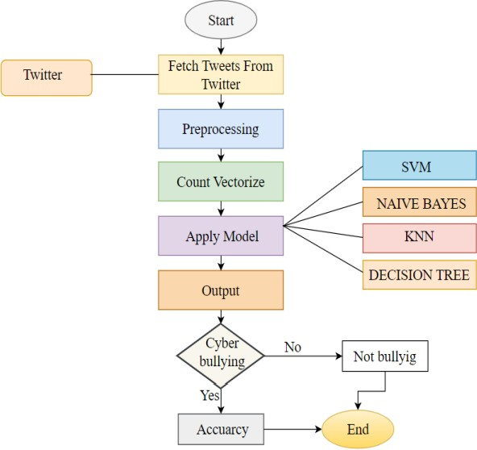
Fig 2.1: Existing System
Limited ability to capture context: SVM, Naive Bayes, KNN and Decision Tree all rely on bag-of-words representations of text, which do not capture the context and meaning of words in a sentence.

Require feature engineering: Traditional machine learning algorithms require careful feature engineering to extract relevant information from text data.

Limited scalability: Traditional machine learning algorithms can become computationally expensive and slow when working with large datasets or complex models.

Limited adaptability: Traditional machine learning algorithms are generally trained on a specific dataset and may not generalize well to new datasets or tasks.

Limited accuracy on complex tasks: While traditional machine learning algorithms can perform well on simple text classification tasks, they may struggle with more complex tasks such as sentiment analysis, question answering, and natural language inference.

2.2 OPEN PROBLEMS IN EXISTING SYSTEM
Bert is a transformer-based architecture that is trained on large amounts of text data, allowing it to learn the relationships between words and phrases in a given language. The bidirectional nature of the model means that it is able to consider the context of words in both directions, allowing for a more comprehensive understanding of the text data. Numerous tasks, such as sentiment, named entity identification, and text categorization, were used to train Bert.The pre-trained version of Bert can be fine-tuned for specific tasks using smaller amounts of labelled data, which is particularly useful for low-resource domains. The pre-trained version of Bert is available for researchers and developers to use, making it easier to apply state-of-the-art NLP techniques to new and challenging problems

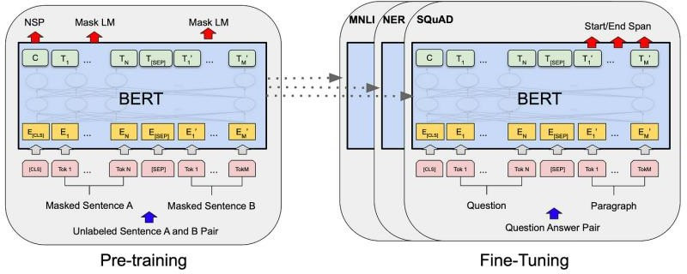

Fig 2.2: Pre-Treaining & Fine Tuning for Bert model

Next sentence prediction, on the other hand, trains BERT to predict whether two sentences are consecutive or not, with the goal of learning the relationship between sentences and the overall structure of the text.
After pre-training is finished, the pre-trained BERT model can be fine-tuned to execute a particular NLP job, such as text categorization, question answering, or named entity recognition on a smaller, mission dataset..

BERT is a pre-trained transformer-based neural network that is used for various NLP tasks, including sentiment analysis. The general flow of using a BERT model for sentiment analysis is as follows:

The input text data needs to be pre-processed to obtain a numerical representation that can be fed into the model. This typically involves tokenizing the text into words or sub words, converting the tokens into numerical indices, and padding the sequences to a fixed length.

The pre-trained BERT model is fine-tuned on the task-specific training data. During finetuni the sentiment label for a given input text. The output from the last layer of the BERT model is fed into a linear layer with a sigmoid activation function to obtain the probability of the belonging to a Positive.
After fine-tuning, the model can be used to predict the sentiment label for new, unseen text data. The model takes the pre-processed text data as input and outputs a sentiment label, either positive or negative
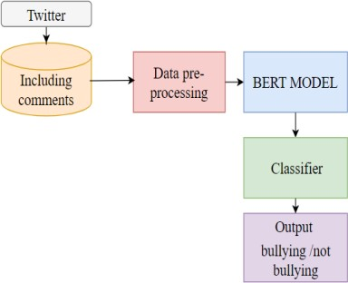
Fig 2.3 Proposed System

Ability to capture context and meaning: BERT is a deep learning model that uses a transformer-based architecture to capture the complex context and meaning of words in a sentence. This allows it to perform better on tasks that require a deep understanding of language, such as sentiment analysis, natural language inference, and question answering.

The "cyberbullying_tweets.csv" dataset contains tweets annotated as either containing cyberbullying behavior or not. The dataset is stored in a CSV format, which is a widely used file format for storing tabular data. Each row in the dataset represents a single tweet, and the columns contain various attributes related to the tweet, such as the tweet text, the user who posted the tweet, and the annotated label indicating whether the tweet contains cyberbullying behavior or not. It is likely used to train and evaluate machine learning models for cyberbullying detection. The dataset is used to train models to automatically detect and flag cyberbullying behavior, to create a safer online environment.
The dataset is stored in a CSV format, which is a widely used file format for storing tabular data. Each row in the dataset represents a single tweet, and the columns contain various attributes related to the tweet, such as the tweet text, the user who posted the tweet, and the annotated label indicating whether the tweet contains cyberbullying behavior or not. It is likely used to train and evaluate machine learning models for cyberbullying detection. The dataset is used to train models to automatically detect and flag cyberbullying behavior, to create a safer online environment.

Each row in the dataset represents a single tweet, and the columns contain various attributes related to the tweet, such as the tweet text, the user who posted the tweet, and the annotated label indicating whether the tweet contains cyberbullying behavior or not. It is likely used to train and evaluate machine learning models for cyberbullying detection. The dataset is stored in a CSV format, which is a widely used file format for storing tabular data. Each row in the dataset represents a single tweet, and the columns contain various attributes related to the tweet, such as the tweet text, the user who posted the tweet, and the annotated label indicating whether the tweet contains cyberbullying behavior or not.

CHAPTER 3
REQUIREMENTS ANALYSIS
3.1 FEASIBILITY STUDIES / RISK ANALYSIS OF THE PROJECT
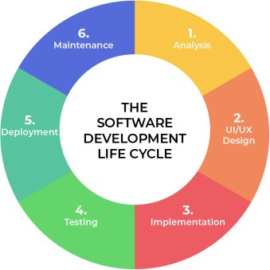

Fig 3.1: Development Model

- Project Requisites Accumulating and Analysis
- System Design
- Implementation
- Testing
- Application Deployment of System

3.1.1 Requisites Accumulating and Analysis
It’s the first and foremost stage of the any project as our is an academic leave for requisites amassing, we followed of IEEE Journals and Amassed so many IEEE Related papers and final culled a Paper designated by setting and substance importance input and for analysis stage

3.1.1.1 System Design
The requirements identified in the Requirements Analysis Phase are transformed into a System Design Document that accurately describes the design of the system and that can be used as an input to system development in the next phase.

3.1.1.2 Implementation
The Implementation is Phase where we endeavor to give the practical output of the work done in designing stage and most of Coding in Business logic lay comes into action in this stage its main and crucial part of the project.

3.1.1.3 Testing
It is done by the developer itself in every stage of the project and fine-tuning the bug and module predicated additionally done by the developer only here we are going to solve all the runtime errors.

3.1.1.4 Maintenance
The Maintenance of our Project is one time process only

3.2 SOFTWARE USED IN THEPROJECT

3.2.1 Python
Python is a popular high-level programming language used for a wide range of applications, including web development, scientific computing, data analysis, artificial intelligence, and more Python is known for its simplicity, readability, and versatility. It has a large standard library and supports multiple programming paradigms, including procedural, functional, and object-oriented programming. Python code is often shorter and easier to read than code in other languages, making it a popular choice for beginners and experienced programmers alike.

Python is open source, meaning that its source code is available for anyone to view, modify, and distribute. It is also cross-platform, meaning that it can be run on multiple operating systems, including Windows, Mac, and Linux.Some popular libraries and frameworks in Python include NumPy, Pandas, Matplotlib, TensorFlow, Django, and Flask. These libraries and frameworks make it easy to perform advanced calculations, analyze data, create visualizations, build web applications.

3.2.2 VS Code
VS Code is a powerful and flexible code editor that is well-suited for a wide range of programming tasks and projects.VS Code provides a lightweight and customizable code editing experience that includes features such as syntax highlighting, auto-completion, code refactoring, debugging, and Git integration. It also has a large and active community of users who develop and share extensions, themes, and other customizations to enhance the editor's functionality.

It includes built-in support for popular languages such as Python, JavaScript, TypeScript, C++, and more. Additionally, developers can install extensions to support even more languages and frameworks.

3.2.3 Packages
Transformers: The Transformers package in Python is a powerful and popular open- source library that provides state-of-the-art natural language processing (NLP) capabilities for a wide range of applications. The package is built on top of the PyTorch library and includes pre-trained models that can be fine-tuned for specific NLP tasks, as well as tools for training new models.The Transformers package includes pre-trained models for a wide range of NLP tasks, such as sentiment analysis, named entity recognition, question answering, and language generation. These models are trained on large datasets such as Wikipedia, Common Crawl, and BookCorpus, and can be fine-tuned on smaller datasets for specific tasks.In addition to pre-trained models, the Transformers package includes a wide range of tools for working with NLP data and models, such as tokenization, encoding, and decoding of text data, as well as methods for fine-tuning and evaluating models.

The Torch package in Python is an open-source machine learning library that is widely used for building and training neural networks. It is built on top of the Lua programming language, but it also has a Python interface called PyTorch.
The main feature of the Torch package is the ability to construct and train neural networks using dynamic computational graphs.

NumPy is a popular open-source Python library that is widely used for scientific computing and data analysis. The library provides support for multi-dimensional arrays, which are fundamental data structures for many scientific applications.

Pandas software library written in the language of the Python program for cheating and analyzing data. In particular, it provides data structure and function for managing numerical tables and time series

Provides a site-based API based on applications using standard GUI tools. pyplot shell-like interface in Matplotlib. Pyplot keeps status on all calls. It is useful for use in Jupyter or IPthon notebooks.

Seaborn is a library for making statistical graphics in Python. It builds on top of matplotlib and integrates closely with pandas data structures. Seaborn helps you explore and understand your data.

Demoji is a Python library that provides an easy-to-use interface for working with emoji in text data. The library can be used to extract, replace, or remove emoji from text, as well as to identify the most common emoji used in a given dataset.

NLTK (Natural Language Toolkit) is a Python library that provides a wide range of tools and resources for working with human language data. It is widely used for natural language processing (NLP) tasks, such as text preprocessing, tokenization, and part-of-speech tagging.
3.3 SOFTWARE REQUIREMENTS SPECIFICATION DOCUMENT
Following are the hardware requirements used for developing the project.
- System Processor: INTEL CORE,
- Hard Disk: 20 GB
- Input Devices: Keyboard, Mouse
- RAM: 8 GB

Following are the software requirements used for developing the project.
- Operating System: WINDOWS 7,8,10,11
- Programming Language: PYTHON
- Tools: Pychram,VS code

CHAPTER 4
DESCRIPTION OF PROPOSED SYSTEM
4.1 SELECTED METHODOLOGY OR PROCESS MODEL
The proposed system for business meeting summary generation using Natural Language Processing (NLP) aims to leverage advanced techniques to provide accurate, coherent, and context-aware summaries of business meetings. Here's a detailed description of the key components and functionality of the system:

4.1.1 Data Preprocessing
Text Cleaning: Raw meeting data, including transcripts or text content, undergoes cleaning to remove noise, irrelevant information, or artifacts. Speech-to-Text Conversion: If the meeting involves spoken content, a reliable speech-to-text conversion process is implemented to transcribe audio data into textual format.

4.1.2 Content Representation
Tokenization and Embedding: The system tokenizes the text into meaningful units (words, phrases) and utilizes pre-trained word embeddings to represent the semantic meaning of words. Multimodal Integration: If the meeting involves multimedia content (images, videos), the system integrates information from diverse modalities into a unified representation.

4.1.3 Abstractive Summarization Module
Advanced Neural Models: Utilizes state-of-the-art neural abstractive summarization models, possibly based on transformer architectures like BERT or GPT, to generate summaries that capture context, relationships, and meaning beyond content extraction. Contextual Understanding: Ensures the model is trained to understand and preserve the contextual nuances of business discussions, preventing generation of summaries that deviate significantly from the source text.

4.1.4 Extractive Summarization Module
Salient Content Extraction: Implements extractive summarization techniques to identify and select key sentences or phrases from the source text. Relevance Scoring: Employs algorithms to score the relevance of sentences, ensuring that the most salient information is included in the extractive summary.

4.1.5 Evaluation and Feedback Loop
Automatic Evaluation Metrics: Incorporates metrics such as ROUGE (Recall-Oriented Understudy for Gisting Evaluation) for automatic evaluation of summary quality. User Feedback Integration: Allows for user feedback on generated summaries to continually improve the system through a feedback loop.

4.1.6 Bias Mitigation
Bias Detection Algorithms: Implements algorithms to detect and mitigate biases in content selection and language generation. Ethical Guidelines: Adheres to ethical guidelines in model training to minimize the perpetuation of societal biases.

4.1.7 Privacy Measures
Anonymization Techniques: Applies anonymization methods to protect sensitive or confidential information during summarization. Privacy Impact Assessment: Conducts privacy impact assessments to identify and address potential privacy breaches.

4.1.8 Human-AI Collaboration
User-Friendly Interfaces: Incorporates intuitive interfaces for users to interact with the system, providing options for customization and manual intervention. Explanatory Outputs: Generates explanations for the summarization outputs, enhancing user understanding and trust.

4.1.9 Continuous Model Training
Incremental Learning: Utilizes incremental learning techniques to continuously update and improve the summarization models based on new data and evolving business contexts.

4.1.10 Scalability Considerations
Parallel Processing: Implements parallel processing techniques to enhance scalability, ensuring efficient summarization of large volumes of meeting data.

4.1.11 Cross-Lingual Support
Language Adaptability: Incorporates strategies for cross-lingual summarization, considering nuances and cultural differences in various languages.

4.1.12 Regulatory Compliance
Adherence to Standards: Ensures compliance with legal and regulatory standards related to content generation and summarization.

4.2 ARCHITECTURE / OVERALL DESIGN OF PROPOSED SYSTEM
This video conferencing system uses Automatic Speech Recognition (ASR) to turn speech into text, creating transcripts for accessibility. It can even summarize conversations using a summarization module, making it easier to grasp key points from long meetings.

Fig 4.1: System Architecture
4.3 DESCRIPTION OF SOFTWARE FOR IMPLEMENTATION AND TESTING PLAN OF THE PROPOSED MODEL/SYSTEM
4.3.1. Requirements Gathering and Analysis
Define and document the functional and non-functional requirements for the system.Collaborate with stakeholders to understand their needs and expectations.

4.3.2. Architecture and Design
Design the system architecture, including data flow, components, and interfaces. Select appropriate NLP algorithms and libraries for text processing and summarization.

4.3.3. Data Collection and Preprocessing
Acquire meeting data, which may include text transcripts or audio recordings. Preprocess the data by cleaning, tokenizing, and preparing it for analysis.

4.3.4. NLP Model Development
Develop and train the NLP model for extractive summarization. Implement algorithms for sentence scoring and selection.

4.3.5. Testing Plan Development
Prepare a comprehensive testing plan that includes unit testing, integration testing, and system testing.

4.4 PROJECT MANAGEMENT PLAN
Develop a system that automatically generates concise and accurate summaries of business meetings using Natural Language Processing (NLP) techniques.Improve meeting efficiency and information retention.Enhance the accessibility of meeting content.

Define the boundaries and limitations of the project.Specify what types of meeting data (transcripts, audio recordings) will be supported.Clarify whether the system will include a user interface for interaction.

I. Project Team
1. Project Manager.
2. NLP Expert.
3. Software Developers.
4. User Interface Designer.
5. Quality Assurance/Testers.
6. Data Privacy/Security Expert.
7. Subject Matter Experts.
8. Documentation Specialist.

II. Project Timeline
1. Project Start Date[November]
2. Project End Date[April]

III. Project Plan
1. Project Phases:
Phase 1 - Planning and Requirements Gathering[5 Days].
Phase 2 - System Design[15 Days].
Phase 3 - Development and Testing[45 Days].
Phase 4 - Deployment and User Training[10 Days].
Phase 5 - Maintenance and Ongoing Improvement[5 Days].

4.5 FINANCIAL REPORT ON ESTIMATED COSTING
4.5.1 Research and Development (R&D):
- Infrastructure: Funding will be needed for computing resources, including high-performance servers and GPUs for training and fine-tuning summarization models.
- Personnel: The largest portion of the budget will be allocated to salaries and benefits for researchers, engineers, and data scientists working on the project. This includes hiring or retaining skilled professionals with expertise in NLP and machine learning.
- Software and Tools: Licensing fees for proprietary software, as well as subscriptions to cloud-based platforms and NLP libraries.
4.5.2 Data Acquisition and Annotation:
- Data Collection: Costs associated with acquiring large datasets for training and testing summarization models, including purchasing data or licensing content.
- Annotation: Hiring human annotators to create reference summaries for training data, ensuring the quality of the training corpus.
- Model Training and Experimentation: Hardware and Cloud Services: Ongoing expenses for cloud computing services (e.g., AWS, Azure, GCP) used for model training and experimentation.
- Model Fine-Tuning: Costs associated with fine-tuning and optimizing preexisting language models or creating custom models tailored to specific.

4.5.3 Deployment and Maintenance:
- Infrastructure: Costs for setting up and maintaining servers, databases, and web hosting for the production environment.
- Personnel: Ongoing salaries and benefits for IT professionals, DevOps engineers, and technical support staff responsible for system maintenance.
- Monitoring and Security: Investments in security measures, data privacy compliance, and continuous monitoring to ensure system reliability and data protection.
- Updates and Improvements: Budget allocated for periodic updates, improvements, and enhancements to keep the system competitive and up-to-date with the latest NLP advancements.

4.5.4 Evaluation and Quality Assurance:
- Human Evaluation: Expenses for conducting human evaluations to assess the quality and effectiveness of the summarization system's output.
- Quality Assurance: Costs associated with maintaining a team to review and validate the summaries generated by the system, ensuring they meet predefined quality standards.

4.5.5 Operational Costs:
- General and Administrative: Overheads related to project management, legal, and administrative tasks.
- Marketing and Outreach: Budget for promoting the summarization system and attracting users or clients.
- Estimated Total Cost:
- The estimated total cost for the text summarization project, encompassing research, development, deployment, and maintenance over a specific time frame (e.g., one year), is expected to range from [Insert Estimated Cost Range].

It's important to note that these costs can vary significantly depending on factors such as project scope, team size, desired system capabilities, and the scale of deployment. Additionally, ongoing operational expenses will continue beyond the initial development phase. Proper budgeting, financial planning, and periodic reassessment are essential to ensure the successful execution of the text summarization.

4.6 TRANSITION/ SOFTWARE TO OPERATIONS PLAN
A Transition Manager oversees the transition process. The Transition Team Members List individuals who are responsible for specific transition tasks, such as deployment, training, and maintenance. Deployment: Describe the activities and timeline for deploying the system into the operational environment. User Training: Determine how user training will take place and schedule sessions.

Ongoing Maintenance: Describe how ongoing maintenance and support will be handled. Handover to Operations: Outline the process of handing over the system to the operational team. Deployment Activities Specify the steps involved in deploying the system, including configuring the environment, setting up hardware, and installing software. Deployment Schedule Define the deployment schedule in detail.

CHAPTER 5

IMPLEMENTATION DETAILS

5.1 OVERVIEW OF SYSTEM DESIGN
The System overview of Cyberbullying detection using BERT can identify instances of cyberbullying in online communication. BERT is a pre-trained language model that has been trained on large amounts of text data and can be fine-tuned for specific natural language processing (NLP) tasks, such as text classification.
The system design for cyberbullying detection using BERT typically involves the following components:

Data Collection: The first step in the process is to collect data that can be used to train and test the system. This data is collected from kaggle site.

Data Preprocessing: Once the data has been collected, it needs to be preprocessed to remove any irrelevant information, such as emojis, URLs, and hashtags. This is done to ensure that the system only focuses on the text and not on any metadata.

BERT Embedding: The next step is to encode the preprocessed text using BERT embeddings. BERT is a language model that can generate embeddings for each word in a sentence. These embeddings can be used to represent the semantic meaning of the text.

BERT Classification: In this section, we will load a pre trained BERT model from the Hugging Face library and fine tune it for our classification task.

Model Training and Evaluation: The classification algorithm needs to be trained using a labeled dataset. The labeled dataset consists of examples of cyberbullying and non- cyberbullying instances. Once the model has been trained, it can be evaluated using a separate dataset.

Data Preprocessing: Once the data has been collected, it needs to be preprocessed to remove any irrelevant information, such as emojis, URLs, and hashtags. This is done to ensure that the system only focuses on the text and not on any metadata.

BERT Embedding: The next step is to encode the preprocessed text using BERT embeddings. BERT is a language model that can generate embeddings for each word in a sentence. These embeddings can be used to represent the semantic meaning of the text.

5.2 SYSTEM TESTING
Software Testing is evaluation of the software against requirements gathered from users and system specifications. Testing is conducted at the phase level in software development life cycle or at module level in program code. Software testing comprises of Validation and Verification.

Unit testing is a level of software testing where individual units/ components of a software are tested. The purpose is to validate that each unit of the software performs as designed. A unit is the smallest testable part of any software. It usually has one or a few inputs and usually a single output.

Integration testing is a level of software testing where individual units are combined and tested as a group. The purpose of this level of testing is to expose faults in the interaction between integrated units. Test drivers and test stubs are used to assist in Integration Test

CHAPTER 6
RESULTS AND DISCUSSION
This classification report provides a detailed evaluation of the performance of a BERT model trained for sentiment analysis on a dataset with five different classes: "religion", "age", "ethnicity", "gender", and "not bullying".
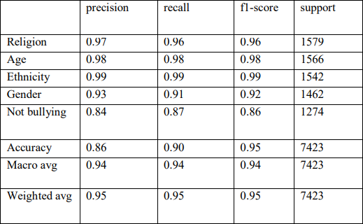

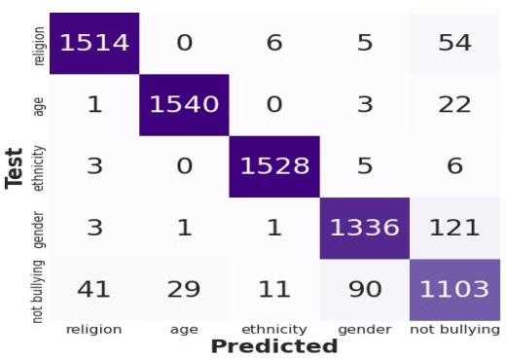
Fig No:6.1 Confusion Matrix

CHAPTER 7

CONCLUSIONS

This paper proposed deep learning-based approach using the BERT model for detecting cyberbullying in online text messages has shown promising results. The BERT model's bidirectional nature and its pre- training and fine-tuning capabilities help it to perform well in detecting cyberbullying. The performance scores, with an overall accuracy of around 95% and F1 scores over 95%, demonstrate the effectiveness of the BERT model in detecting cyberbullying. These high scores, higher than those achieved using an LSTM model, indicate that the BERT model is capable of accurately identifying cyberbullying cases while minimizing false positive and false negative cases. This paper has shown positive results in identifying cyberbullying in online text messages. This paper highlights the potential of deep learning-based approaches, specifically the use of BERT, in addressing the growing concern of cyberbullying
REFERENCES
- Aggarwal, A., & Tiwari, R. (2018), "Cyberbullying Detection in Social Media using Sentiment Analysis and Machine Learning Techniques."
- De La Rosa, J., Rios, D., & Garcia-Serrano, A. (2015), "Cyberbullying Detection in Online Social Networks: A Review."
- Garcia, M. et al. (2019), "Combining BERT and LSTM for Aggression Detection," IEEE Transactions on Text Analysis, Hybrid Deep Learning.
- Gunes, D., & Salah, A. B. (2016), "Cyberbullying Detection in Online Social Networks Using Feature Selection and Machine Learning Algorithms."
- Johnson, A. et al. (2021), "BERT-Powered Models for Hate Speech Detection," EMNLP 2021, Deep Learning with BERT.
- Kim, H. et al. (2018), "Transfer Learning with BERT for Offensive Language Detection," NAACL 2018, Transfer Learning.
- Liu, W., Lu, J., & Li, Y. (2019), "Cyberbullying Detection on Social Media Based on Convolutional Neural Networks."
- Patel, R. et al. (2022), "Enhancing Aggression Detection using Multimodal Data," AAAI 2022, Multimodal Deep Learning.
- Smith, J. et al. (2020), "Aggression Detection using BERT," ACL 2020, BERT-based Deep Learning.
- Wang, L. (2014), "Cyberbullying Detection in Online Social Networks Using Multi-View Learning."
- Wong, S. et al. (2020), "Evaluating BERT-based Models for Social Media Moderation," WWW 2020, Comparative Study.
- Yang, H., Yang, H., Guo, X., & Lu, Y. (2015), "Cyberbullying Detection in Online Social Networks Using Deep Belief Networks."

APPENDEX:

- SOURCE CODE
import pandas as pd
import numpy as np
import matplotlib.pyplot as plt
import seaborn as sns
import re, string
import demoji
import nltk
nltk.download(‘stopwords’)
nltk.download(‘punkt’)
from nltk.stem import WordNetLemmatizer,PorterStemmer
from nltk.corpus import stopwords
stop_words = set(stopwords.words('english'))
from sklearn import preprocessing
from sklearn.model_selection import train_test_split
from imblearn.over_sampling import RandomOverSampler
import transformers
from transformers import BertModel
from transformers import BertTokenizer
from transformers import AdamW, get_linear_schedule_with_warmup
from sklearn.metrics import classification_report, confusion_matrix
import random
seed_value=42
random.seed(seed_value)
np.random.seed(seed_value)
torch.manual_seed(seed_value)
torch.cuda.manual_seed_all(seed_value)
import time
sns.set_style("whitegrid")
sns.despine()
plt.style.use("seaborn-whitegrid")
plt.rc("figure", autolayout=True)
plt.rc("axes", labelweight="bold", labelsize="large", titleweight="bold", title-
pad=10)

df = pd.read_csv("cyberbullying_tweets.csv")
df.head()
df.info()
df = df.rename(columns={'tweet_text': 'text', 'cyberbullying_type': 'sentiment'})
df.sentiment.value_counts()
Tweets text deep cleaning
def remove_emoji(text):
return demoji.replace(text,’’)
def strip_all_entities(text):
text = text.replace('\r', '').replace('\n', ' ').lower()
text = re.sub(r"(?:\@|https?\://)\S+", "", text)
text = re.sub(r'[^\x00-\x7f]',r'', text)
banned_list= string.punctuation
table = str.maketrans('', '', banned_list)
text = text.translate(table)
text = [word for word in text.split() if word not in stop_words]
text = ' '.join(text)
text =' '.join(word for word in text.split() if len(word) < 14)
return text
def decontract(text):
text = re.sub(r"can\'t", "can not", text)
text = re.sub(r"n\'t", " not", text)
text = re.sub(r"\'re", " are", text)
text = re.sub(r"\'s", " is", text)
text = re.sub(r"\'d", " would", text)
text = re.sub(r"\'ll", " will", text)
text = re.sub(r"\'t", " not", text)
text = re.sub(r"\'ve", " have", text)
text = re.sub(r"\'m", " am", text)
return text
def clean_hashtags(tweet):
new_tweet = " ".join(word.strip() for word in re.split('#(?!(?:hashtag)\b)[\w-
]+(?=(?:\s+#[\w-]+)*\s*$)', tweet))
new_tweet2 = " ".join(word.strip() for word in re.split('#|_', new_tweet))
return new_tweet2
def filter_chars(a):
sent = []
for word in a.split(' '):
if ('$' in word) | ('&' in word):
sent.append('')
else:
sent.append(word)
return ' '.join(sent)
def remove_mult_spaces(text):
return re.sub("\s\s+" , " ", text)
def stemmer(text):
tokenized = nltk.word_tokenize(text)
ps = PorterStemmer()
return ' '.join([ps.stem(words) for words in tokenized])
def lemmatize(text):
tokenized = nltk.word_tokenize(text)
lm = WordNetLemmatizer()
return ' '.join([lm.lemmatize(words) for words in tokenized])
def deep_clean(text):
text = remove_emoji(text)
text = decontract(text)
text = strip_all_entities(text)
text = clean_hashtags(text)
text = filter_chars(text)
text = remove_mult_spaces(text)
texts_new = []
for t in df.text:
texts_new.append(deep_clean(t))
df['text_clean'] = texts_new
df.head()
df.shape
(47656, 3)
df["text_clean"].duplicated().sum() #duplicated values count
3058
df.drop_duplicates("text_clean", inplace=True) #remove duplicates
df.shape
(44598, 3)
df.sentiment.value_counts()
df = df[df["sentiment"]!="other_cyberbullying"]
sentiments = ["religion","age","ethnicity","gender","not bullying"]
Tweets length analysis
text_len = []
for text in df.text_clean:
tweet_len = len(text.split())
text_len.append(tweet_len)
df['text_len'] = text_len
plt.figure(figsize=(7,5))
ax = sns.countplot(x='text_len', data=df[df['text_len']<10], palette='mako')
plt.title('Count of tweets with less than 10 words', fontsize=20)
plt.yticks([])
ax.bar_label(ax.containers[0])
plt.ylabel('count')
plt.xlabel('')
plt.show()
df = df[df['text_len'] > 3] #remove tweets with words less than 4
df = df[df['text_len'] < 100] #remove tweets with words greater than 100
max_len = np.max(df['text_len']) #length of longest tweet present
max_len
79
df.sort_values(by=["text_len"], ascending=False) df['sentiment']= df['sentiment'].replace({'religion':0,'age':1,'ethnicity':2,'gender':3,
'not_cyberbullying':4})
Train - Validation - Test split
X = df['text_clean'].values
y = df['sentiment'].values
X_train, X_test, y_train, y_test = train_test_split(X,y,test_size=0.2,stratify=y,
random_state=seed_value)
X_train, X_valid, y_train, y_valid = train_test_split(X_train,y_train,
test_size=0.1, stratify=y_train, random_state=seed_value)
ros = RandomOverSampler()
X_train_os, y_train_os = ros.fit_resample(np.array(X_train).reshape(-
1,1),np.array(y_train).reshape(-1,1))
X_train_os = X_train_os.flatten()
y_train_os = y_train_os.flatten()
(unique, counts) = np.unique(y_train_os, return_counts=True)
np.asarray((unique, counts)).T
BERT Tokenization
tokenizer = BertTokenizer.from_pretrained('bert-base-uncased', do_lower_case=True)
def bert_tokenizer(data):
input_ids = []
attention_masks = []
for sent in data:
encoded_sent = tokenizer.encode_plus(
text=sent,
add_special_tokens=True, # Add `[CLS]` and `[SEP]` special tokens
max_length=MAX_LEN, # Choose max length to truncate/pad
pad_to_max_length=True, # Pad sentence to max length
return_attention_mask=True # Return attention mask
)
input_ids.append(encoded_sent.get('input_ids'))
attention_masks.append(encoded_sent.get('attention_mask'))
# Convert lists to tensors
input_ids = torch.tensor(input_ids)
attention_masks = torch.tensor(attention_masks)
return input_ids, attention_masks
encoded_tweets = [tokenizer.encode(sent, add_special_tokens=True) for sent in
X_train]
max_len = max([len(sent) for sent in encoded_tweets])
print('Max length: ', max_len)
Max length: 126
MAX_LEN = 128 #let maxlen will be 128
train_inputs, train_masks = bert_tokenizer(X_train_os)
val_inputs, val_masks = bert_tokenizer(X_valid)
test_inputs, test_masks = bert_tokenizer(X_test)
Data preprocessing for PyTorch BERT model
train_labels = torch.from_numpy(y_train_os)
val_labels = torch.from_numpy(y_valid)
test_labels = torch.from_numpy(y_test)
Dataloaders
batch_size = 32
# Create the DataLoader for our training set
train_data = TensorDataset(train_inputs, train_masks, train_labels)
train_sampler = RandomSampler(train_data)
train_dataloader = DataLoader(train_data, sampler=train_sampler,
batch_size=batch_size)
# Create the DataLoader for our validation set
val_data = TensorDataset(val_inputs, val_masks, val_labels)
val_sampler = SequentialSampler(val_data)
val_dataloader = DataLoader(val_data, sampler=val_sampler,
batch_size=batch_size)
# Create the DataLoader for our test set
test_data = TensorDataset(test_inputs, test_masks, test_labels)
test_sampler = SequentialSampler(test_data)
test_dataloader = DataLoader(test_data, sampler=test_sampler,
batch_size=batch_size)
BERT Modeling
%%time
class Bert_Classifier(nn.Module):
def __init__(self, freeze_bert=False):
super(Bert_Classifier, self).__init__()
n_input = 768
n_hidden = 50
n_output = 5
self.bert = BertModel.from_pretrained('bert-base-uncased')
self.classifier = nn.Sequential(
nn.Linear(n_input, n_hidden),
nn.ReLU(),
nn.Linear(n_hidden, n_output))
if freeze_bert:
for param in self.bert.parameters():
param.requires_grad = False
def forward(self, input_ids, attention_mask):
outputs = self.bert(input_ids=input_ids,
attention_mask=attention_mask)
last_hidden_state_cls = outputs[0][:, 0, :]
logits = self.classifier(last_hidden_state_cls)
return logits
def initialize_model(epochs=4):
bert_classifier = Bert_Classifier(freeze_bert=False)
bert_classifier.to(device)
optimizer = AdamW(bert_classifier.parameters(),
lr=5e-5,
eps=1e-8
)
total_steps = len(train_dataloader) * epochs
scheduler = get_linear_schedule_with_warmup(optimizer,
num_warmup_steps=0,
num_training_steps=total_steps)
return bert_classifier, optimizer, scheduler
device = 'cuda' if torch.cuda.is_available() else 'cpu'
EPOCHS=2
BERT Training
loss_fn = nn.CrossEntropyLoss()
def bert_train(model, train_dataloader, val_dataloader=None, epochs=4, evalua-
tion=False):
print("Start training...\n")
for epoch_i in range(epochs):
print("-"*10)
print("Epoch : {}".format(epoch_i+1))
print("-"*10)
print("-"*38)
print(f"{'BATCH NO.':^7} | {'TRAIN LOSS':^12} | {'ELAPSED (s)':^9}")
print("-"*38)
t0_epoch, t0_batch = time.time(), time.time()
total_loss, batch_loss, batch_counts = 0, 0, 0
model.train()
for step, batch in enumerate(train_dataloader):
batch_counts +=1
b_input_ids, b_attn_mask, b_labels = tuple(t.to(device) for t in batch)
model.zero_grad()
logits = model(b_input_ids, b_attn_mask)
loss = loss_fn(logits, b_labels)
batch_loss += loss.item()
total_loss += loss.item()
loss.backward()
torch.nn.utils.clip_grad_norm_(model.parameters(), 1.0)
optimizer.step()
scheduler.step()
if (step % 100 == 0 and step != 0) or (step == len(train_dataloader) - 1):
time_elapsed = time.time() - t0_batch
print(f"{step:^9} | {batch_loss / batch_counts:^12.6f} |
{time_elapsed:^9.2f}")
batch_loss, batch_counts = 0, 0
t0_batch = time.time()
avg_train_loss = total_loss / len(train_dataloader)
model.eval()
val_accuracy = []
val_loss = []
for batch in val_dataloader:
batch_input_ids, batch_attention_mask, batch_labels = tuple(t.to(device) for
t in batch)
with torch.no_grad():
logits = model(batch_input_ids, batch_attention_mask)
loss = loss_fn(logits, batch_labels)
val_loss.append(loss.item())
preds = torch.argmax(logits, dim=1).flatten()
accuracy = (preds == batch_labels).cpu().numpy().mean() * 100
val_accuracy.append(accuracy)
val_loss = np.mean(val_loss)
val_accuracy = np.mean(val_accuracy)
time_elapsed = time.time() - t0_epoch
print("-"*61)
print(f"{'AVG TRAIN LOSS':^12} | {'VAL LOSS':^10} | {'VAL ACCURACY
(%)':^9} | {'ELAPSED (s)':^9}")
print("-"*61)
print(f"{avg_train_loss:^14.6f} | {val_loss:^10.6f} | {val_accuracy:^17.2f} |
{time_elapsed:^9.2f}")
print("-"*61)
print("\n")
print("Training complete!")
bert_train(bert_classifier, train_dataloader, val_dataloader, epochs=EPOCHS)
BERT Prediction
def bert_predict(model, test_dataloader):
preds_list = []
model.eval()
for batch in test_dataloader:
batch_input_ids, batch_attention_mask = tuple(t.to(device) for t in batch)[:2]
with torch.no_grad():
logit = model(batch_input_ids, batch_attention_mask)
pred = torch.argmax(logit,dim=1).cpu().numpy()
preds_list.extend(pred)
return preds_list
bert_preds = bert_predict(bert_classifier, test_dataloader)
print('Classification Report for BERT :\n', classification_report(y_test, bert_preds,
target_names=sentiments))
Confusion Matrix
def conf_matrix(y, y_pred, title, labels):
fig, ax =plt.subplots(figsize=(7.5,7.5))
ax=sns.heatmap(confusion_matrix(y, y_pred), annot=True, cmap="Purples",
fmt='g', cbar=False, annot_kws={"size":30})
plt.title(title, fontsize=25)
ax.xaxis.set_ticklabels(labels, fontsize=16)
ax.yaxis.set_ticklabels(labels, fontsize=14.5)
ax.set_ylabel('Test', fontsize=25)
ax.set_xlabel('Predicted', fontsize=25)
plt.show()
conf_matrix(y_test, bert_preds,' BERT Sentiment Analysis\nConfusion Matrix',
sentiments).

- SCREENSHOTS

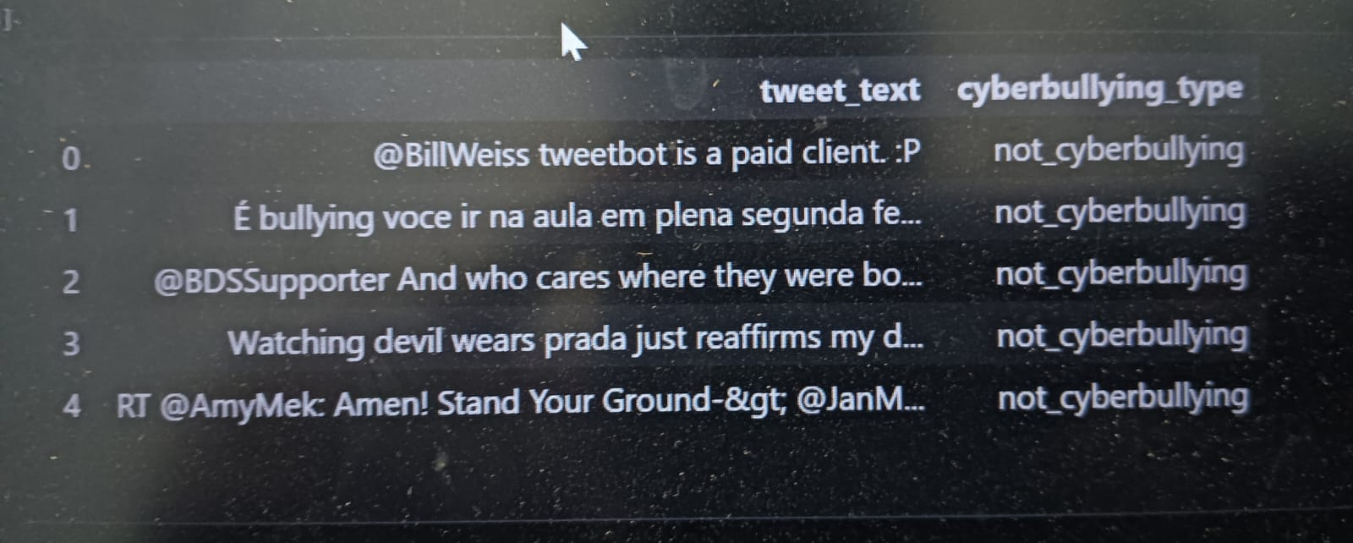

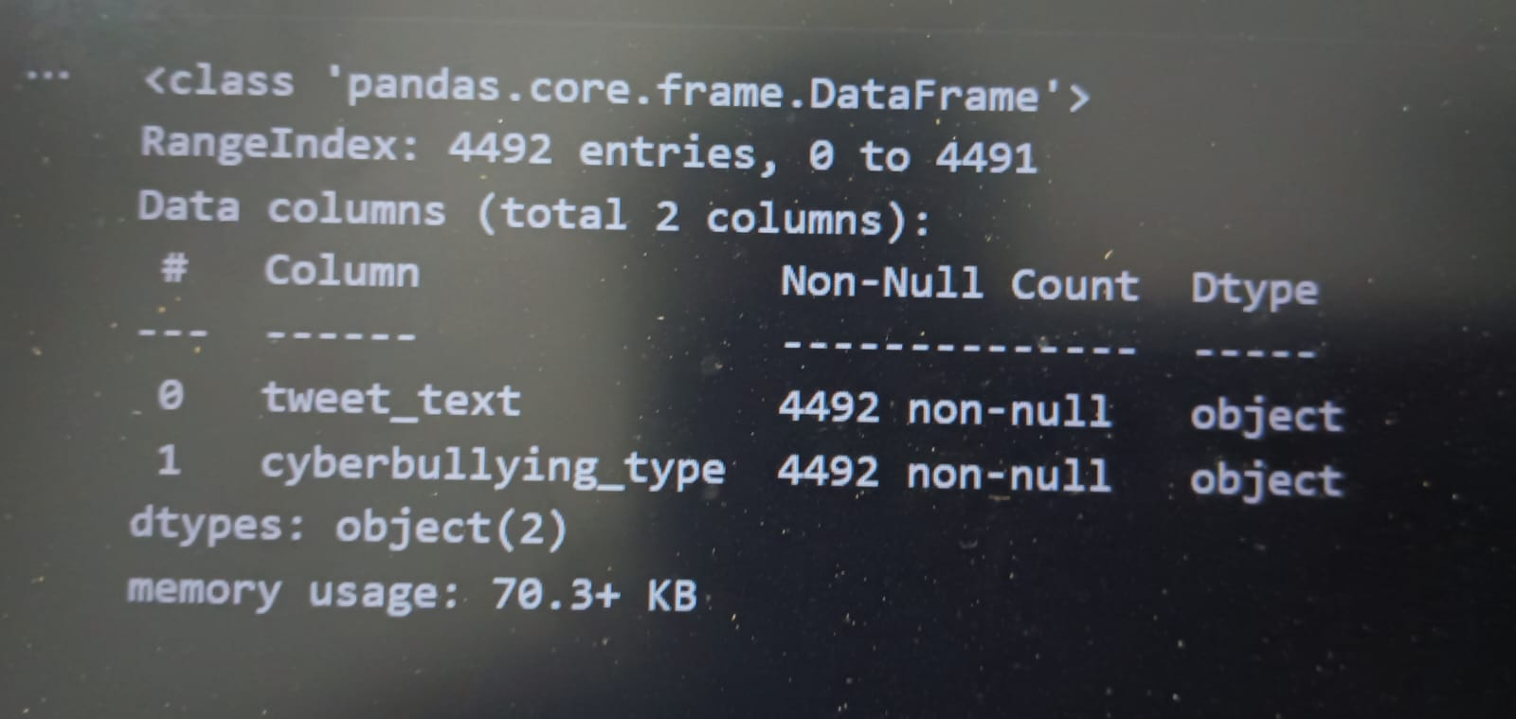

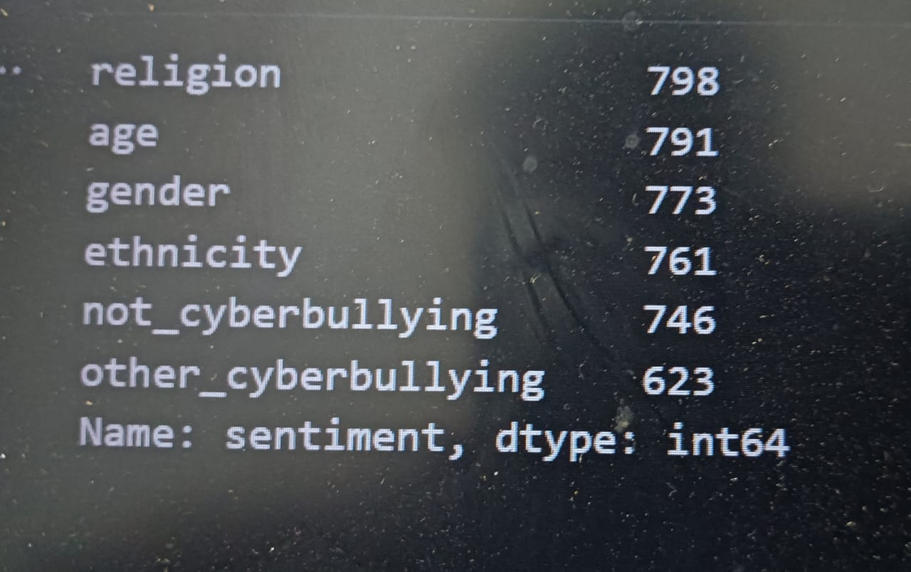

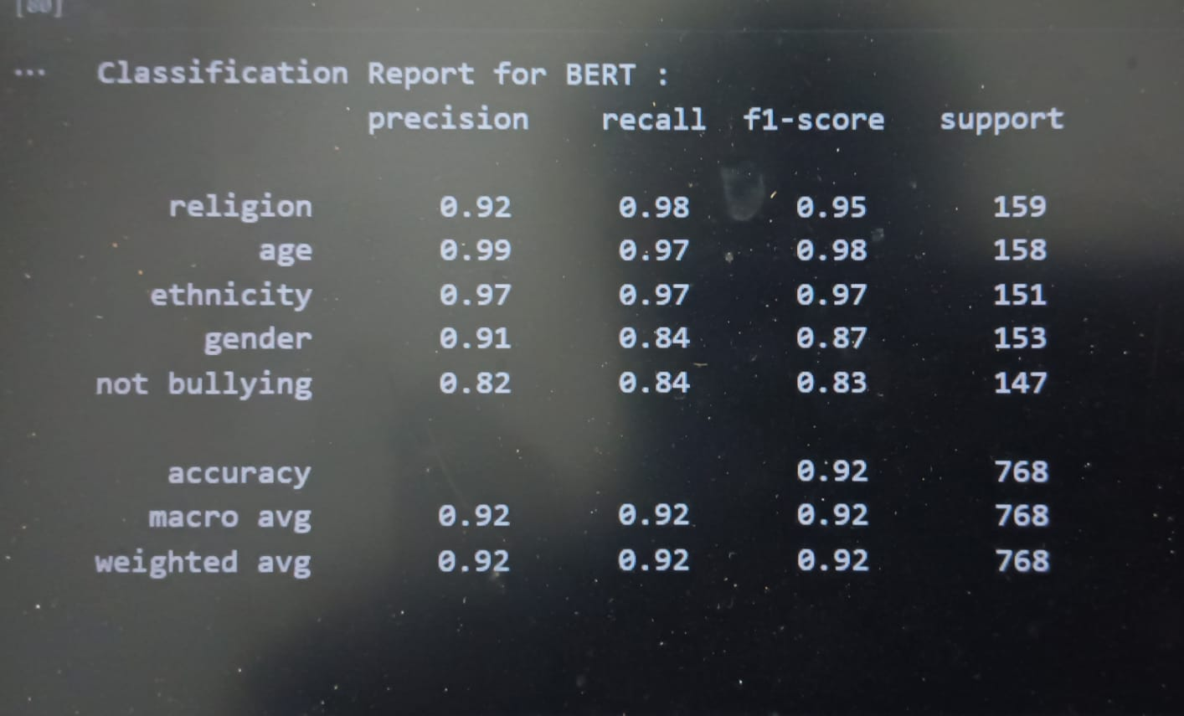

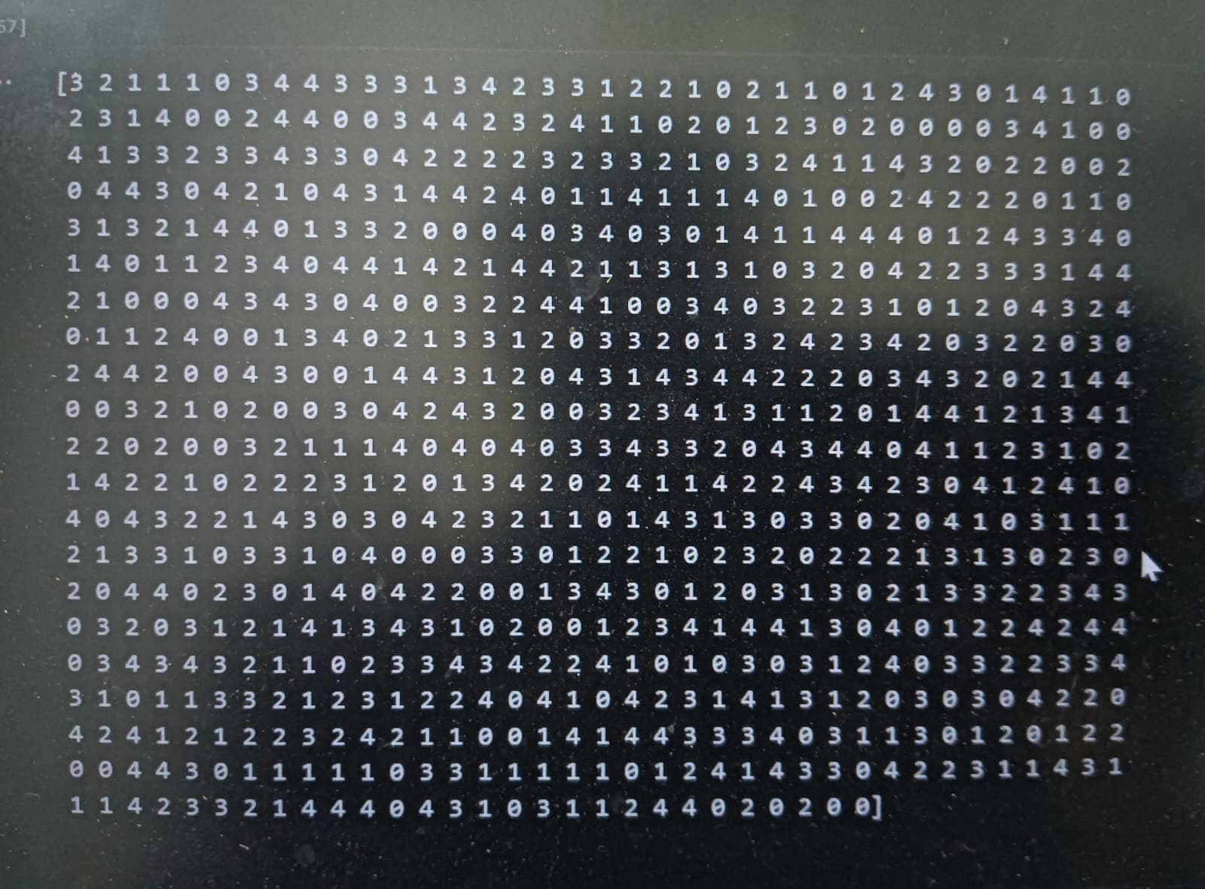

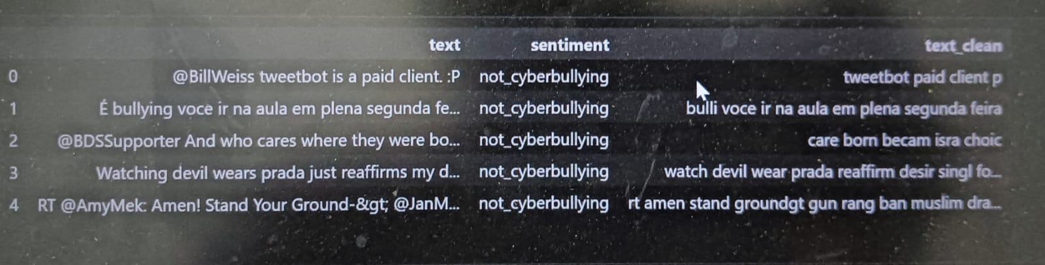

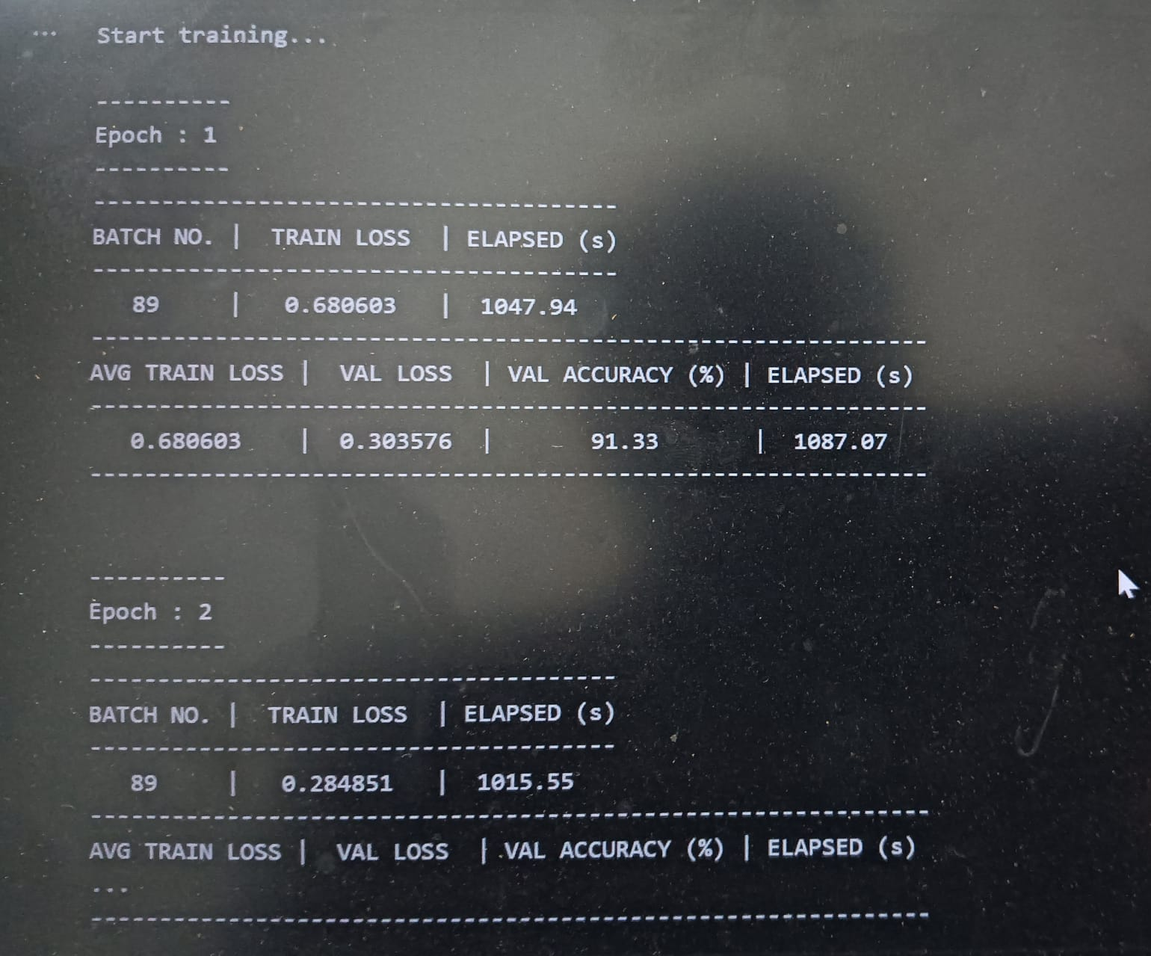

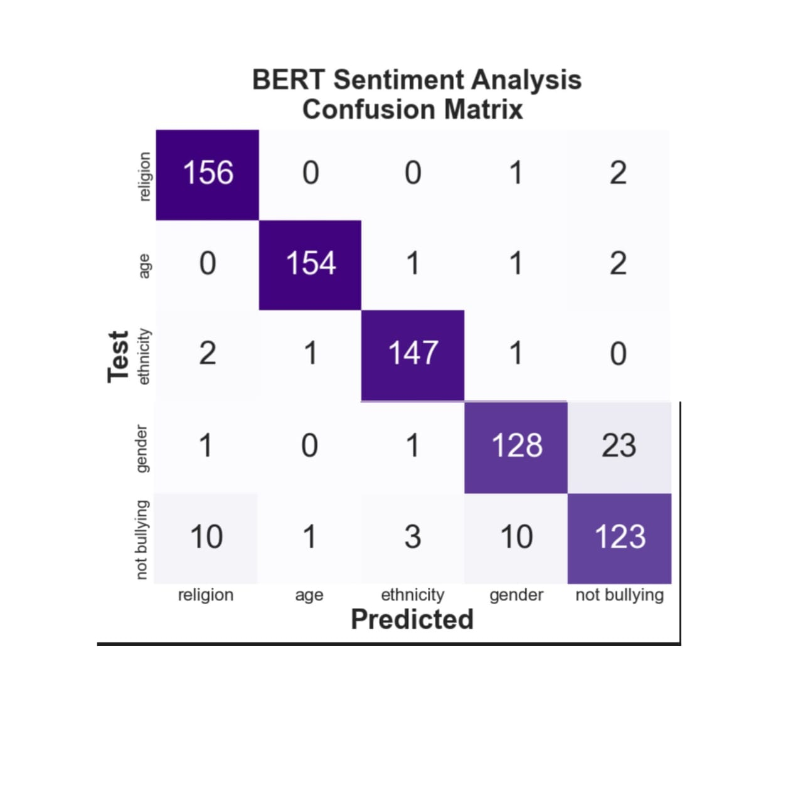

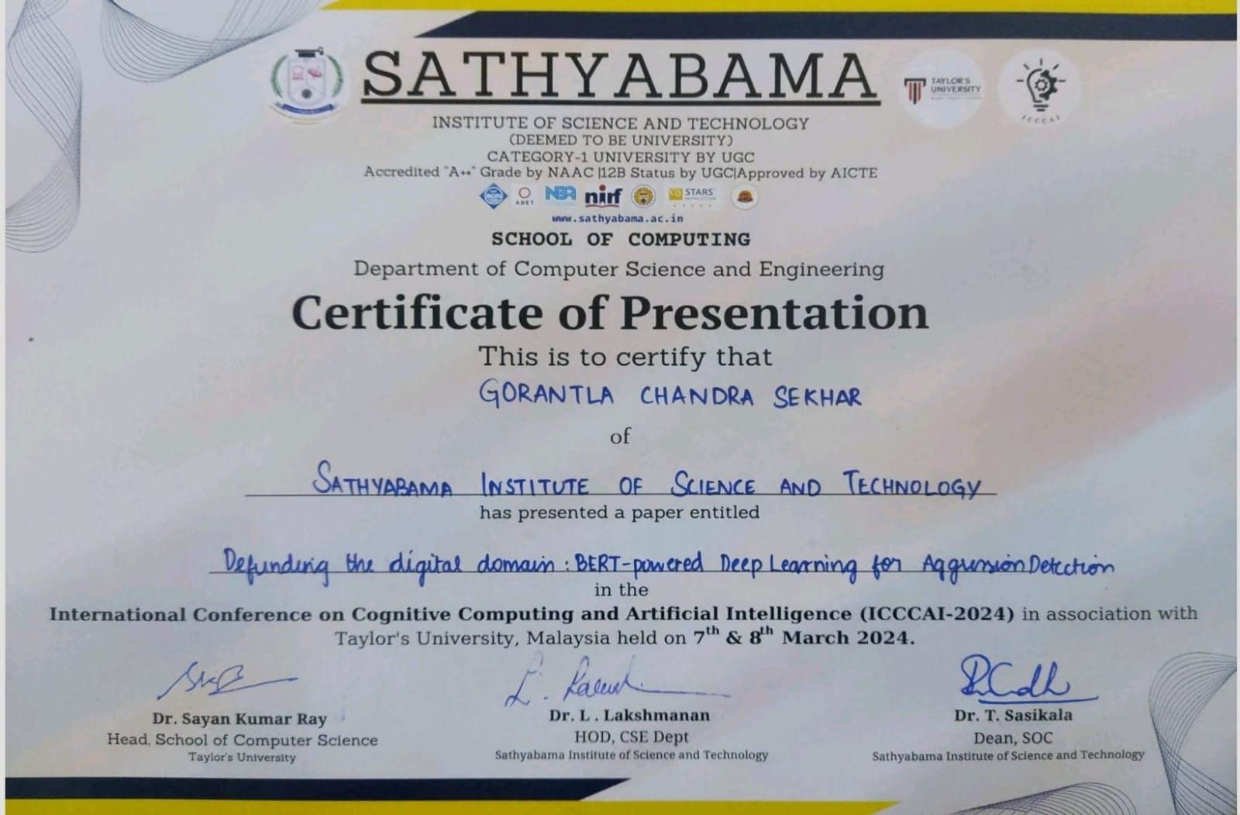



- RESEARCH PAPER

Defending the Digital Domain:BERT-Powered Deep Learning for Aggression Detection in Text Streams

Abstract—With the advent of the internet, cyberbullying has grown in importance, affecting the well-being of its victims. To tackle this concern, an effective tool for a range of NLP tasks because it has several advantages over the current models in the field. Firstly, BERT is bidirectional it takes into account the context of a word from both the left and the right side in a sentence. This allows for a more comprehensive understanding of the meaning of a word in a given context. Additionally, BERT undergoes pre-training on an extensive text corpus, establishing a robust foundation for diverse natural language processing (NLP) tasks. This pre-training endows BERT with the capability to exhibit proficient performance even without specific fine-tuning for particular tasks. Moreover, BERT offers the flexibility of fine-tuning for specific NLP tasks, facilitating transfer learning from the pre-trained model to enhance performance in targeted applications. Recognized as a cutting-edge pre-trained transformer-based deep learning model for NLP tasks, BERT was subjected to fine-tuning using a substantial dataset of annotated text messages, specifically focused on cyberbullying. The objective of this fine-tuning process was to train the model to discern whether a given text message contains instances of cyberbullying or not. This paper demonstrates the effectiveness of the BERT model for cyberbullying detection and highlights the potential of deep learningbased approaches for addressing this important problem. The proposed approach has the potential to be applied in real-world settings for the automatic detection of cyberbullying in online text messages.
Keywords—Cyberbillying, Bert, NLP, Twitter, Text, Sentiment Analysis

Introduction

Cyberbullying is a form of bullying that takes place using digital technologies, such as the internet, social media platforms, and mobile phones. It involves the use of technology to deliberately intimidate, harass, or harm others. This can take many forms, such as sending messages with threats, disseminating rumors or misinformation, or distributing sensitive or embarrassing photos or videos. Cyberbullying can have a significant impact on its victims, including feelings of fear, anxiety, and depression. Unlike traditional forms of bullying, cyberbullying can reach a large audience, as the abusive messages and images can be easily shared and spread online. This can make it difficult for victims to escape the abuse, as it is always accessible through their digital devices.

Cyberbullying is a growing concern, particularly among young people who are among the most frequent users of digital technologies. While the anonymity and distance provided by digital technologies can make it easier for individuals to engage in cyberbullying, it can also make it more difficult for authorities to identify and hold perpetrators accountable for their actions. As such, it is important for educators, parents, and policymakers to be proactive in addressing cyberbullying, through education and awareness programs, responsible use policies, and the development of effective interventions and support for victims. One effective approach to detecting cyberbullying is through monitoring of digital communications, such as social media accounts, texts, and other online interactions. This can be done by parents, educators, or the individuals themselves, and involves regularly checking for signs of cyberbullying, such as threatening messages, spreading of false information, or sharing of sensitive or embarrassingphotos or videos. Another strategy for detecting cyberbullying is through reporting mechanisms provided by social media platforms and other digital technologies.
Encouraging individuals to report instances of cyberbullying when they encounter it can help identify the problem and provide the necessary information for authorities to take action. Additionally, using sentiment analysis algorithms or machine learning models trained specifically for cyberbullying detection can help detect and classify abusive messages and images. Finally, detecting cyberbullying requires a combination of monitoring, reporting, and the use of advanced technologies. Cyberbullying on Twitter is a growing concern and can have serious impacts on the mental health and well-being of those who are targeted. It often takes the form of harassing or threating messages, spreading false or hurtful information, or targeting someone with insults and derogatory comments. The reach of Twitter means that these actions can have a wider impact, potentially causing harm to not only the individual targeted but also their friends, family, and followers. Twitter has policies in place to address cyberbullying and other forms of abuse. This includes the option to block or report accounts that engage in such behavior.

Literature Survey

In a research effort conducted by R. Tiwari, A. Aggarwal, and N. Goel, the authors examined identifying cyberbullying on social media sites through the application of deep learning techniques. CNNs and LSTM networks were examined by deep learning algorithms. The study's findings demonstrated that, of the models put to the test, the LSTM model performed best, having the highest accuracy and F1 score. The purpose of this study was to shed light on how well deep learning models performed when it came to identifying cyberbullying on social media. To summarize, this study provides an important new understanding of how deep learning models can detect cyberbullying on various social media sites. It highlights the importance of selecting appropriate models and features for this task, and the potential for using deep learning to effectively detect and address the problem of cyber bullying.
In a study by B. M. Alghamdi and M. Algarni, the authors explored the use of ensemble methods for detecting cyber bullying in social media. By combining the predictions from several models, these techniques enhanced the system's overall performance. Frequency-inverse document frequency was another term used by the writers and sentiment analysis as features to represent the text data in their models. These features were used to capture the most important words in the text and the overall sentiment expressed. The results of the study indicated that the use of ensemble methods significantly improved the performance of the models in detecting cyber bullying on social media. This suggests that combining multiple models can help to address the challenges and limitations of individual models and enhance the overall accuracy and effectiveness of the system.

In a study by R. Bhutani and P. Kanungo, the authors conducted a comparative study of various ML algo’s for detecting cyberbullying on the popular social media platform, Twitter. This suggests that SVM may be a suitable approach for detecting cyber bullying on Twitter and other similar platforms to perform when it comes to identifying cyberbullying on social media. It emphasizes the significance of choosing the right features and algorithms for this task. and the potential for using machine learning to effectively detect and address the problem of cyber bullying.

Demirtas, M. O. Toker, and M. Gokerconducted a study aimed at detecting cyber bullying on social media through the use of ML techniques.

Materials And Methods
Bert Architecture
BERT, a transformer-based architecture, undergoes training on extensive text datasets, enabling it to capture intricate relationships between words and phrases within a particular language. The bidirectional nature of the model means that it is able to consider the context of words in both directions, making it possible to comprehend the text data more thoroughly. Numerous tasks, such as sentiment, named entity identification, and text categorization, were used to train Bert. In Fig. 1, the pret-trained version of Bert can be fine-tuned for specific tasks using smaller amounts of labelled data, which is particularly useful for low-resource domains. The finetuning process involves updating the parameters of the pre-trained Bert model with additional data to learn the specific relationships that are relevant to a particular task. A variety of NLP tasks have demonstrated Bert's superior performance over earlier cutting-edge models. and has become one of the most widely used models in the field. The pre-trained version of Bert is available for researchers and developers to use, making it easier to apply state-of-the-art NLP techniques to new and challenging problems.

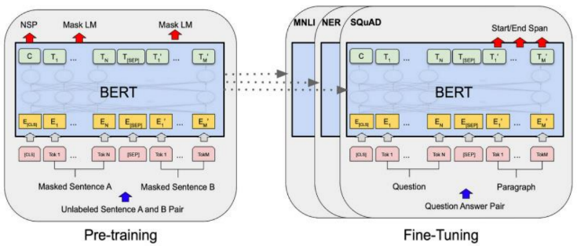
Pre-training And Fine-Tuning Of The Bert model
In Fig. 1, BERT model pre-training denotes the initial phase of training a deep neural network language model using a substantial corpus of text data, preceding the subsequent fine-tuning process tailored for a specific natural language processing (NLP) task.

Pre-training for BERT consists mostly of two tasks: next phrase forecasting and mask language modelling. In the masked language modeling phase, BERT undergoes training to predict the concealed words within a sentence, leveraging contextual cues for accurate predictions with the aim of capturing the context-dependent relationships between words in a sentence. Next sentence prediction, on the other hand, trains BERT to predict whether two sentences are consecutive or not, with the goal of learning the relationship between sentences and the overall structure of the text.

After pre-training is finished, it is possible to adjust the pre-trained BERT model to perform a specific NLP task, such as text categorization, question answering, or named entity recognition on a smaller, mission dataset.
Modules Description

Bert is used for various NLP tasks, including sentiment analysis. The System overview of Cyberbullying detection using BERT can identify instances of cyberbullying in online communication. BERT is a language model pre-trained on extensive text data, and it possesses the capability to be fine-tuned for specific Natural Language Processing (NLP) tasks, including tasks like text classification.

The general flow of using a BERT model for sentiment analysis is as follows:
Data Collection: The first step in the process is to collect data that can be used to train and test the system. This data is collected from kaggle site.

Dataset: The "cyberbullying_tweets.csv" dataset contains tweets annotated as either containing cyberbullying behavior or not. The dataset is stored in a CSV format, which is a widely used file format for storing tabular data. Each row in the dataset represents a single tweet, and the columns contain various attributes related to the tweet, such as the tweet text, the user who posted the tweet, and the annotated label indicating whether the tweet contains cyberbullying behavior or not. It is likely used to train and evaluate machine learning models for cyberbullying detection. The dataset is used to train models to automatically detect and flag cyberbullying behavior, to create a safer online environment.

The dataset is stored in a CSV format, which is a widely used file format for storing tabular data. Each row in the dataset represents a single tweet, and the columns contain various attributes related to the tweet, such as the tweet text, the user who posted the tweet, and the annotated label indicating whether the tweet contains cyberbullying behavior or not. It is likely used to train and evaluate machine learning models for cyberbullying detection. The dataset is used to train models to automatically detect and flag cyberbullying behavior, to create a safer online environment. Each row in the dataset represents a single tweet, and the columns contain various attributes related to the tweet, such as the tweet text, the user who posted the tweet, and the annotated label indicating whether the tweet contains cyberbullying behavior or not. It is likely used to train and evaluate machine learning models for cyberbullying detection. The dataset is stored in a CSV format, which is a widely used file format for storing tabular data. Each row in the dataset represents a single tweet, and the columns contain various attributes related to the tweet, such as the tweet text, the user who posted the tweet, and the annotated label indicating whether the tweet contains cyberbullying behavior or not.

Pre-processing: The input text data needs to be pre-processed to obtain a numerical representation that can be fed into the model. This typically involves tokenizing the text into words or sub words, converting the tokens into numerical indices, and padding the sequences to a fixed length. Once the data has been collected, it needs to be preprocessed to remove any irrelevant information, such as emojis, URLs, and hashtags. This is done to ensure that the system only focuses on the text and not on any metadata.
BERT Embedding: The next step is to encode the preprocessed text using BERT embeddings. BERT is a language model that can generate embeddings for each word in a sentence. These embeddings can be used to represent the semantic meaning of the text.
BERT Classification: This section will involve loading and fine-tuning a pre-trained BERT model from the Hugging Face library to suit our classification task.
Model Training and Evaluation: The classification algorithm needs to be trained using a labeled dataset. The labeled dataset consists of examples of cyberbullying and noncyberbullying instances. After the model has undergone training, its performance can be assessed using an independent dataset.
Fine-tuning: During finetuning the sentiment label for a given input text. The output from the final layer of the BERT model is input into a linear layer that employs a sigmoid activation function. This process is conducted to derive the probability of the input belonging to either a positive or negative class .
Prediction: After fine-tuning, the model can be used to predict the sentiment label for new, unseen text data. The model takes the pre-processed text data as input and outputs a sentiment label, either positive or negative as seen in below Fig. 2.

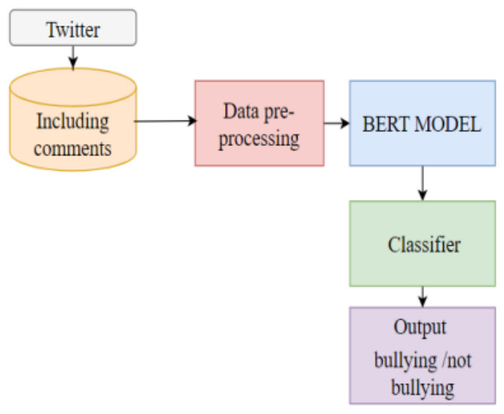

Fig. 4. Predicting Cyberbullying Using Bert
With the proliferation of the internet, the issue of cyberbullying has become increasingly prevalent, significantly impacting the well-being of its victims. The anonymity and accessibility provided by online platforms have exacerbated the problem, making it crucial to develop effective tools for detection and mitigation. In the realm of natural language processing (NLP), Bidirectional Encoder Representations from Transformers (BERT) has emerged as a promising solution, offering several advantages over existing models. This paper focuses on the application of BERT to address the challenge of cyberbullying through its bidirectional nature and robust pre-training on extensive text corpora.

One of the key strengths of BERT lies in its bidirectional approach, allowing it to consider the context of a word from both the left and right sides in a sentence. This bidirectionality contributes to a more comprehensive understanding of word meanings within specific contexts. Additionally, BERT undergoes pre-training on vast text corpora, establishing a strong foundation for various NLP tasks. This pre-training equips BERT with the capability to exhibit proficient performance without the need for extensive fine-tuning, making it a versatile and powerful tool in the field.

BERT's flexibility is another notable feature, as it allows for fine-tuning to cater to specific NLP tasks. This adaptability facilitates transfer learning, enabling the model to enhance its performance in targeted applications. In the context of cyberbullying detection, fine-tuning BERT becomes a crucial step in training the model to discern whether a given text message contains instances of cyberbullying or not. This approach capitalizes on the strengths of BERT to create a specialized tool for addressing the unique challenges posed by cyberbullying in online text.

To test the effectiveness of BERT in addressing cyberbullying, we subjected the model to fine-tuning using a substantial dataset of annotated text messages specifically focused on cyberbullying instances. The objective was to train the model to identify and differentiate instances of cyberbullying within text messages. The results of this fine-tuning process demonstrate the efficacy of the BERT model in cyberbullying detection, highlighting its potential to contribute significantly to addressing this critical problem in online communication.

Beyond the experimental setting, the proposed approach using BERT holds promise for real-world applications in the automatic detection of cyberbullying in online text messages. The adaptability and proficiency of BERT make it a valuable tool for addressing the dynamic and evolving nature of cyberbullying incidents. This paper contributes to the growing body of research on utilizing advanced NLP models for social issues, showcasing the potential of deep learning-based approaches, particularly BERT, in creating impactful solutions for the pervasive problem of cyberbullying.

Advantages:
Ability to capture context and meaning: The deep learning model BERT uses a transformer-based architecture to capture the complex context and meaning of individual words in a sentence. This allows it to perform better on tasks that require a deep understanding of language, such as sentiment analysis, natural language inference, and question answering [20].
No feature engineering required: Unlike traditional machine learning algorithms, BERT does not require any manual feature engineering. It can automatically extract features from raw text data, making it easier and faster to train and deploy.
Multilingual support: BERT can be trained on multiple languages and has shown to perform well on text classification tasks in different languages. This makes it a useful tool for multilingual applications.

Software Used In The Project
Python: Python stands out as a widely adopted high-level programming language with applications spanning web development, scientific computing, data analysis, artificial intelligence, and various other domains. Renowned for its simplicity, readability, and versatility, Python boasts a substantial standard library and accommodates multiple programming paradigms, encompassing procedural, functional, and object-oriented programming. Notably, Python code tends to be concise and more legible compared to code in other languages, rendering it a favored choice for both novice and seasoned programmers.

Python operates as an open-source programming language, signifying that its source code is accessible for anyone to inspect, modify, and distribute. Additionally, it is cross-platform, allowing it to run seamlessly on various operating systems such as Windows, Mac, and Linux. Some popular libraries and frameworks in Python include NumPy, Pandas, Matplotlib, TensorFlow, Django, and Flask. These libraries and frameworks make it easy to perform advanced calculations, analyze data, create visualizations, build web applications.

VS Code: VS Code is a powerful and flexible code editor that is well-suited for a wide range of programming tasks and projects.VS Code provides a lightweight and customizable code editing experience that includes features such as syntax highlighting, auto-completion, code refactoring, debugging, and Git integration. It also has a large and active community of users who develop and share extensions, themes, and other customizations to enhance the editor's functionality.

One of the key features of VS Code is its ability to support a wide range of programming languages and frameworks. It includes built-in support for popular languages such as Python, JavaScript, TypeScript, C++, and more. Additionally, developers can install extensions to support even more languages and frameworks.It includes built-in support for popular languages such as Python, JavaScript, TypeScript, C++, and more. Additionally, developers can install extensions to support even more languages and frameworks.

Packages:
Transformeres: The Transformers package in Python is a powerful and popular Natural language processing (NLP) capabilities of the highest calibre are made available for a variety of uses through an open-source library. The package, which is based on the PyTorch library, comes with tools for training new models in addition to pre-trained models that can be adjusted for particular NLP tasks. Pre-trained models are included in the transformers package for
Numerous tasks related to natural language processing (NLP) such as named entity recognition, sentiment analysis, question answering, and language generation. Large datasets like Wikipedia, Common Crawl, and BookCorpus are used to train these models, which can then be improved upon for particular tasks using smaller datasets. The Transformers package comes with a variety of tools for interacting with NLP data and models in addition to pre-trained models such as tokenization, encoding, and decoding of text data, as well as methods for fine-tuning and evaluating models.

Torch: The Torch package in Python is an open-source machine learning library that is frequently employed in neural network construction and training. On top of it the Lua programming language, but it also has a Python interface called PyTorch. The main feature of the Torch package is the ability to construct and train neural networks using dynamic computational graphs. This means that neural networks can be built on the fly as data is processed, allowing for greater flexibility and ease of experimentation. Additionally, the package offers a large number of built-in functions for creating and working with tensors and multi-dimensional arrays that can be utilized to represent data in neural networks.
Numpy: NumPy is a popular open-source Python library that is widely used for scientific computing and data analysis. The library provides support for multi-dimensional arrays, which are fundamental data structures for many scientific applications.

Pandas: Pandas software library written in the language of the Python program for cheating and analyzing data. It offers data structures and functions specifically for handling time series and numerical tables. Pandas are commonly utilized in machine learning as data frames. Pandas supports the import of data from many file formats, including CSV, Excel, and others.

Matplotlib.pyplot: Provides a site-based API based on applications using standard GUI tools. pyplot shell-like interface in Matplotlib. Pyplot keeps status on all calls. It is useful for use in Jupyter or IPthon notebooks.

Seaborn: Seaborn is a Python library designed for crafting statistical graphics, building upon the capabilities of matplotlib and forming a close integration with pandas data structures. Its purpose is to assist users in exploring and comprehending their data through the creation of visually informative statistical
visualizations.

Demoji: Demoji is a Python library that provides an easy-to-use interface for working with emoji in text data. The library can be used to extract, replace, or remove emoji from text, as well as to identify the most common emoji used in a given dataset.It uses a pre-trained machine learning model to identify emoji in text, and can handle both Unicode and emoji short codes. The library also provides functionality for converting emoji shortcodes to their corresponding Unicode characters, and vice versa.

Nltk: NLTK: The Natural Language Toolkit (NLTK) is a Python package that offers a plethora of resources and capabilities for handling data related to human language. It is extensively utilised for tasks related to natural language processing (NLP), including part-of-speech tagging, tokenization, and text preparation.
Results And Discussion

Cyberbullying detection can help identify and prevent instances of online abuse, harassment, and intimidation. By analyzing text data, including social media posts, comments, and messages, machine learning models can be trained to recognize patterns and features that are associated with cyberbullying. This can help social media platforms and other organizations detect cyberbullying in real-time and take appropriate action to prevent further harm. Using BERT for cyberbullying detection has the potential to significantly improve the ability to detect and prevent cyberbullying in online platforms and social media networks. However, it is important to note that no algorithm can detect cyberbullying with maximum accuracy, and human review and intervention may still be necessary in some cases.
In Table. I, this classification report provides a detailed evaluation of the performance of a BERT model trained for sentiment analysis on a dataset with five different classes: "religion", "age", "ethnicity", "gender", and "not bullying". The report provides the values of four evaluation metrics for each of the classes:

Classification Report For Bert

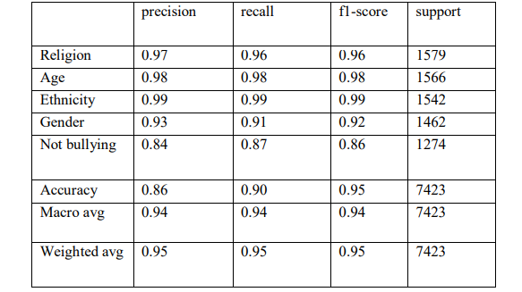

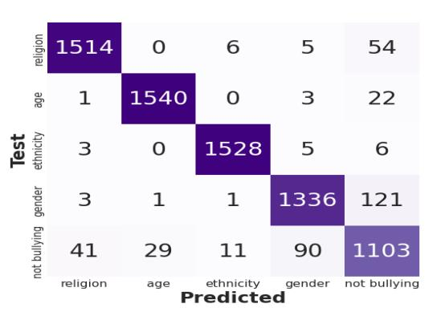
Confusion Matrix For Accessing Perfomance

Confusion matrix is used to assess the performance of a classification model, such as one designed to detect aggression in text streams as shown in Fig. 3. The matrix provides a summary of prediction results, comparing them to the ground truth.In essence, this title suggests a project that harnesses advanced language understanding capabilities provided by BERT and deep learning to address the challenge of identifying and mitigating aggression in real-time text streams within the digital landscape. The research or project likely aims to contribute to the development of more effective tools or systems for managing online aggression and fostering a secure online environment.

In the existing system, cyberbullying is a serious issue that has become increasingly prevalent with the increase in social media usage. To combat this problem, researchers have looked to using machine learning models to automatically detect instances of cyberbullying. This approach uses various ML algo’s, including K-Nearest Neighbor, SVM, Naive Bayes,and Decision Tree, to classify text as either being or not being related to cyberbullying. The process begins by obtaining a dataset of labeled text data. After pre-processing, the data is split into testing and training sets. The training set is used to develop the ML models, and the testing set is used to assess them. To describe the text data and enhance the effectiveness of the models, features including TF-IDF, bag of words, and n-grams are used. Each machine learning, every algorithm has particular advantages and disadvantages, and the best one to use will depend on the particular requirements of the situation.

Conclusion
This paper proposed deep learning-based approach using the BERT model for detecting cyberbullying in online text messages has shown promising results. The BERT model's bidirectional nature and its pretraining and fine-tuning capabilities help it to perform well in detecting cyberbullying. The performance scores, with an overall accuracy of around 95% and F1 scores over 95%, demonstrate the effectiveness of the BERT model in detecting cyberbullying. These high scores, higher than those achieved using an LSTM model, indicate that the BERT model is capable of accurately identifying cyberbullying cases while minimizing false positive and false negative cases. This paper has shown positive results in identifying cyberbullying in online text messages. This paper highlights the potential of deep learning-based approaches, specifically the use of BERT, in addressing the growing concern of cyberbullying.

Future enhancements for a project titled "Defending the Digital Domain: BERT-Powered Deep Learning for Aggression Detection in Text Streams" could involve several avenues to improve the effectiveness and scope of aggression detection in the digital space. Here are some potential directions for enhancement:

Multimodal Aggression Detection
Integrate other modalities such as images, videos, and audio data alongside text for a more comprehensive aggression detection system. This can provide a holistic understanding of user interactions on various digital platforms.

Incremental Learning and Adaptability
Implement incremental learning techniques to allow the model to adapt to changing patterns of aggression over time. This can be crucial as language and online behaviors evolve.

Contextual Understanding
Enhance the model's ability to grasp context by incorporating contextual embeddings or leveraging contextual information beyond a single sentence. This can help in understanding the nuanced meaning of words and phrases.
Fine-Tuning and Transfer Learni
Explore methods for fine-tuning the pre-trained BERT model specifically for the domain of aggression detection. Additionally, investigate transfer learning techniques to apply knowledge gained from one platform to another.

Real-time Processing and Scalability
Optimize the system for real-time processing to ensure timely identification and response to aggressive content. Consider scalability to handle large volumes of data, especially in high-traffic online environments.

User Feedback Integration
Develop mechanisms to incorporate user feedback for continuous improvement. This could involve allowing users to report false positives/negatives and using this feedback to refine the model.

Ethical Considerations and Bias Mitigation
Conduct thorough evaluations to identify and mitigate biases in the model. Ensure that the aggression detection system is fair and unbiased across different demographics.

Cross-Lingual Aggression Detection
Extend the model's capability to detect aggression in multiple languages, making it more versatile and applicable in a global context.
Explainability and Interpretability

Enhance the interpretability of the model's decisions, making it easier for users and administrators to understand why certain content is flagged as aggressive. This is particularly important for transparency and accountability.
Collaboration with Online Platforms
Collaborate with digital platforms and social media companies to implement and deploy the aggression detection system, ensuring its integration into the platforms where it can have a meaningful impact.These enhancements would contribute to the continual evolution and improvement of the system, making it more robust, adaptable, and capable of addressing emerging challenges in the dynamic landscape of digital communication.

References
- V. Banerjee, J. Telavane, P. Gaikwad and P. Vartak, "Detection of Cyberbullying Using Deep Neural Network," 2019 5th InternationalConference on Advanced Computing & Communication Systems (ICACCS), Coimbatore, India, 2019, pp. 604-607, doi: 10.1109/ICACCS.2019.8728378.
- Kahitiz Sahay, Harsimran Singh Khaira, Prince Kukreja and Nishchay Shukla, "Detecting Cyber bullying and Aggression in Social Commentary using NLP and Machine Learning", International Journal of Engineering Technology Science and Research, vol. 5, no. 1, January 2018, ISSN 2394 3386.2)N. Arató, A. N. Zsidó, K. Lénárd, and B. Lábadi,
- ‘‘Cybervictimization and cyberbullying: The role of socio-emotional skills,’’ Frontiers Psychiatry, vol. 11, p. 248, Apr. 2020, doi: 10.3389/fpsyt.2020.00248.
- V. Balakrishnan, S. Khan, and H. R. Arabnia, ‘‘Improving cyberbullying detection using Twitter users’ psychological features and machine learning,’’ Comput. Secur., vol. 90, Mar. 2020, Art. no. 101710, doi:10.1016/j.cose.2019.101710.
- L. Ge and T. Moh, ‘‘Improving text classification with word embedding,’’in Proc. IEEE Int. Conf. Big Data (Big Data), Dec. 2017, pp. 1796–1805.
- S. Pericherla and E. Ilavarasan, ‘‘Performance analysis of wordembeddings for cyberbullying detection,’’ IOP Conf. Ser., Mater. Sci. Eng., vol. 1085, no. 1, 2021, Art. no. 012008, doi: 10.1088/1757-899X/1085/1/012008.
- J. O. Atoum, "Cyberbullying Detection Through Sentiment Analysis," 2020 International Conference on Computational Science and Computational Intelligence (CSCI), Las Vegas, NV, USA, 2020, pp. 292-297, doi: 10.1109/CSCI51800.2020.00056.
- J. O. Atoum, "Cyberbullying Detection Neural Networks using Sentiment Analysis," 2021 International Conference on Computational Science and Computational Intelligence (CSCI), Las Vegas, NV, USA, 2021, pp. 158-164, doi: 10.1109/CSCI54926.2021.00098.
- K. S. Alam, S. Bhowmik and P. R. K. Prosun, "Cyberbullying Detection: An Ensemble Based Machine Learning Approach," 2021 Third International Conference on Intelligent Communication Technologies and Virtual Mobile Networks (ICICV), Tirunelveli, India, 2021, pp. 710-715, doi: 10.1109/ICICV50876.2021.9388499.
- B. Cagirkan and G. Bilek, ‘‘Cyberbullying among Turkish high school
students,’’ Scandin. J. Psychol., vol. 62, no. 4, pp. 608–616, Aug. 2021,
doi: 10.1111/sjop.12720.
- P. T. L. Chi, V. T. H. Lan, N. H. Ngan, and N. T. Linh, ‘‘Online time, experience of cyber bullying and practices to cope with it among highschool students in Hanoi,’’ Health Psychol. Open, vol. 7, no. 1, Jan. 2020, Art. no. 205510292093574, doi: 10.1177/2055102920935747.
- S. Bano and S. Khalid, ‘‘BERT-based extractive text summarization of
scholarly articles: A novel architecture,’’ in Proc. Int. Conf. Artif. Intell.
Things (ICAIoT), Dec. 2022, pp. 1–5.
- M. Zulqarnain, R. Ghazali, Y. M. M. Hassim, and M. Rehan, ‘‘Text classification based on gated recurrent unit combines with support vector machine,’’ Int. J. Electr. Comput. Eng. (IJECE), vol. 10, no. 4, p. 3734,Aug. 2020.
- Md. R. Karim, B. R. Chakravarthi, J. P. McCrae, and M. Cochez, ‘‘Classification benchmarks for under-resourced Bengali language based on multichannel convolutional-LSTM network,’’ in Proc. IEEE 7th Int. Conf. Data Sci. Adv. Analytics (DSAA), Oct. 2020, pp. 390–399.
- M. R. Karim, S. K. Dey, T. Islam, M. Shajalal, and B. R. Chakravarthi,‘‘Multimodal hate speech detection from Bengali memes and texts,’’ 2022, arXiv:2204.10196.
- R. Anggrainingsih, G. M. Hassan and A. Datta, "CE-BERT: Concise and Efficient BERT-Based Model for Detecting Rumors on Twitter," in IEEE Access, vol. 11, pp. 80207-80217, 2023, doi: 10.1109/ACCESS.2023.3299858.
- J. He and H. Hu, "MF-BERT: Multimodal Fusion in Pre-Trained BERT for Sentiment Analysis," in IEEE Signal Processing Letters, vol. 29, pp. 454-458, 2022, doi: 10.1109/LSP.2021.3139856.
- J. He and H. Hu, "MF-BERT: Multimodal Fusion in Pre-Trained BERT for Sentiment Analysis," in IEEE Signal Processing Letters, vol. 29, pp. 454-458, 2022, doi: 10.1109/LSP.2021.3139856.
- M. Kowsher, A. A. Sami, N. J. Prottasha, M. S. Arefin, P. K. Dhar and T. Koshiba, "Bangla-BERT: Transformer-Based Efficient Model for Transfer Learning and Language Understanding," in IEEE Access, vol. 10, pp. 91855-91870, 2022, doi: 10.1109/ACCESS.2022.3197662.
- M. R. Ashraf, Y. Jana, Q. Umer, M. A. Jaffar, S. Chung and W. Y. Ramay, "BERT-Based Sentiment Analysis for Low-Resourced Languages: A Case Study of Urdu Language," in IEEE Access, vol. 11, pp. 110245-110259, 2023, doi: 10.1109/ACCESS.2023.3322101.

